1. **Create A Spring Boot Application**
2. **Create A database as below**

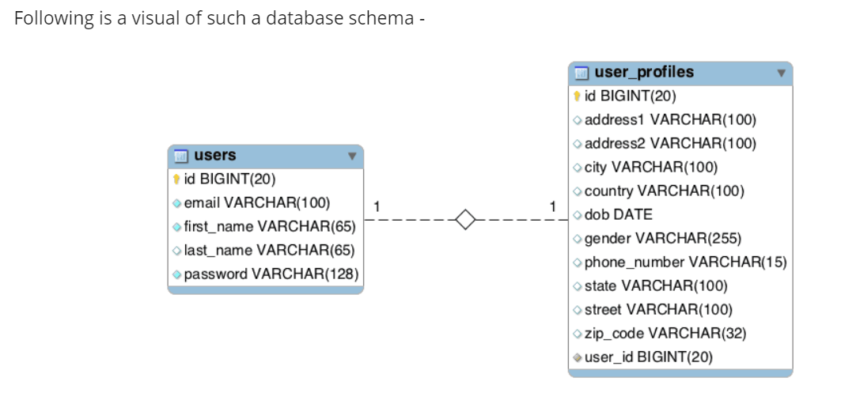

1. **Create Get method to get all the database**
2. **Create getbyID method to get the data for any specific user**
3. **Create Post mapping to create new users**
4. **Create Put mapping and pass the id also to update the record**
5. **Delete Api to delete the record**

**Business Logic:**

**You should have the valid email id entered by the user otherwise Throw exception saying email id is not valid**

**Password length should be 10 character and there should be one special character also**

**Create A ENUM for county and match with valid county and it there is not valid county Raise Exception saying Country is not Found in our Database**